**Defect Report 6**

**Issue location**

* Main page

**Issue details and actual behaviour**

* Filter doubles up on results when progress and priority selections are made

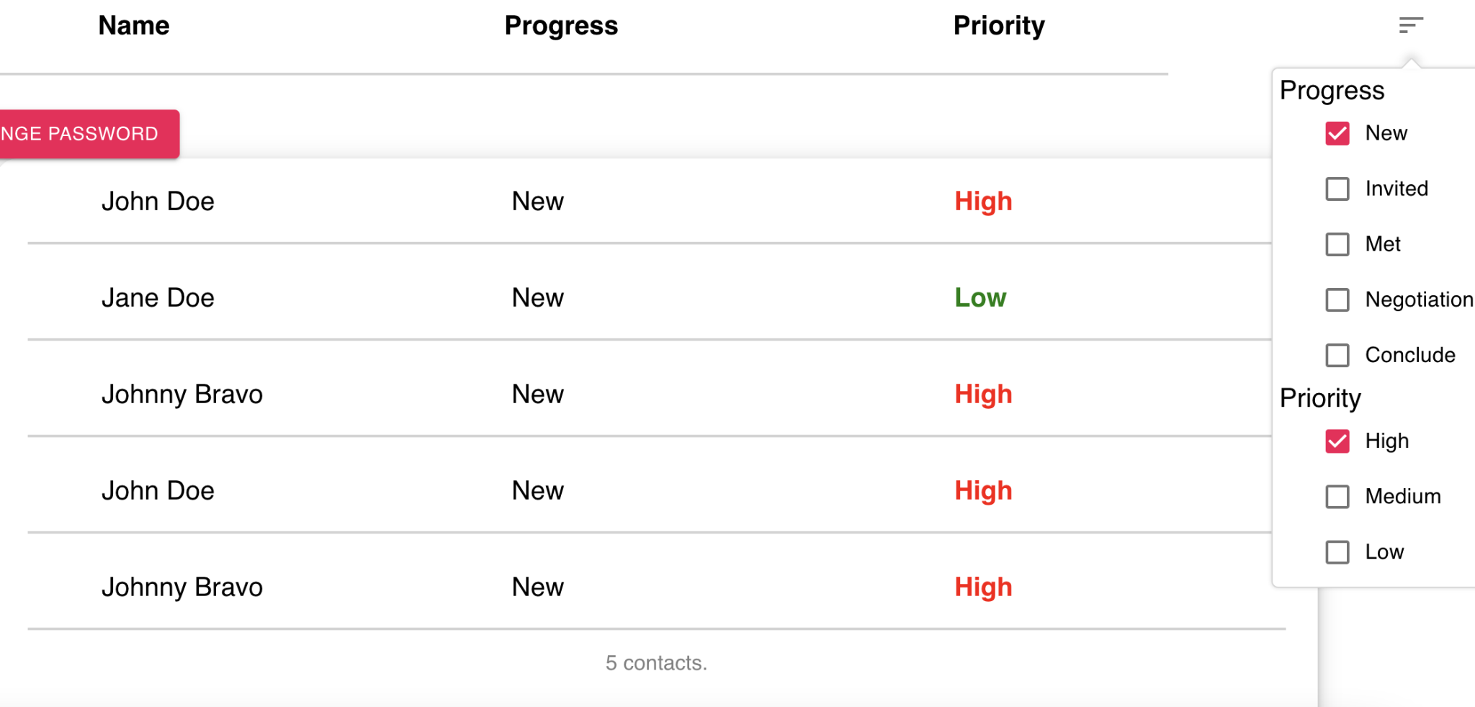

**Expected behaviour**

* When selecting filters from progress and priority, only one of each result with the selected filters should show up